Ex.No:1: Simulation of FDMA in MATLAB

Aim: To simulate a Frequency Division Multiple Access (FDMA) system using MATLAB and analyze its communication performance in terms of channel bandwidth, data rate, and signal-to-noise ratio (SNR).
Objective 1:
To simulate an FDMA system by allocating individual frequency channels to multiple users and determine the channel bandwidth assigned to each user.
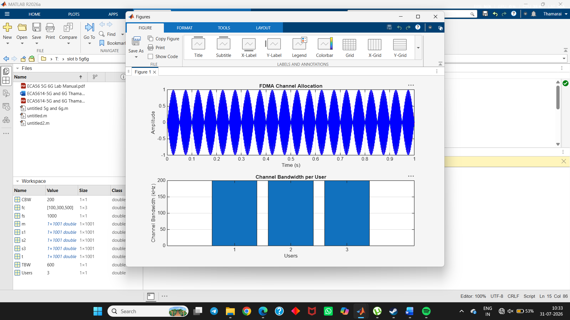
Objective 2:
To calculate the data rate achieved by each user in the FDMA system based on the allocated channel bandwidth.
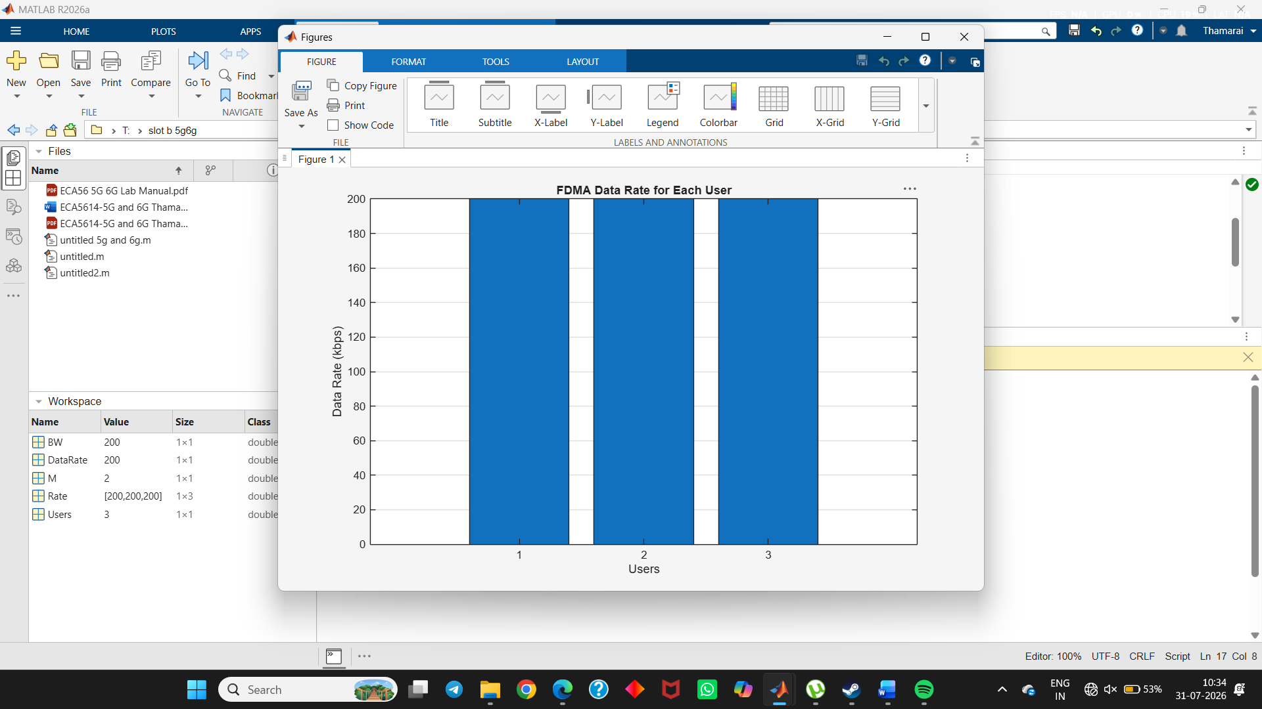
Objective 3:
To evaluate the communication quality of the FDMA system by calculating the Signal-toNoise Ratio (SNR) for different users.
